
Collage of Electrical and Mechanical Engineering
Software Department
Fundamental to programming II (SWEG2103) Project

Payroll management system
Group-6
- Sifen Iyasu -----------------------------------------------------CEP0103/14
- Abenezer Yonathan ----------------------------------------CEP0006/14
- Eyob Hailemariam-------------------------------------------CEP0041/14

Submitted to: - Mr. Felix Edesa
Submission date: - 17/09/2023

Introduction

Payroll management is an essential function in any organization, as it involves the calculation and distribution of employee salaries and benefits. With the increasing complexity of payroll processes and the need for accurate and timely payments, organizations are turning to automated payroll management systems to streamline their operations.
This document presents a comprehensive overview of a payroll management system developed using the C++ programming language. C++ is a powerful and versatile programming language known for its efficiency and performance, making it an ideal choice for developing complex systems like payroll management.
The payroll management system outlined in this document aims to automate various payroll tasks, including employee data management, salary calculation, tax deductions, and payment processing. By leveraging the capabilities of C++, this system ensures accuracy, efficiency, and data security, while reducing manual errors and administrative overhead.
This document will provide a detailed description of the system's architecture, key features, and functionality. It will also cover the design principles, data structures, algorithms, and libraries used in the development process. Additionally, it will discuss the system's user interface, customization options, and integration with external systems, such as accounting software and time attendance systems.
Furthermore, this document will highlight the benefits of implementing a payroll management system in C++, including improved productivity, cost savings, compliance with legal and regulatory requirements, and enhanced employee satisfaction. It will also address potential challenges and considerations for successful implementation and maintenance.
Whether you are an organization looking to automate your payroll processes or a software developer interested in learning about payroll management system development in C++, this document serves as a valuable resource. By understanding the concepts, methodologies, and best practices discussed here, you can effectively design, develop, and deploy a robust and efficient payroll management system using C++.

Problem Statement
Problem: Manual Data Entry
Description: The current system requires manual data entry for adding employee details.
Solution: The code allows the user to add new employees by entering their details, eliminating the need for manual data entry. This reduces the chances of human errors and saves time.
Problem: Calculation Errors
Description: The current system lacks proper calculations for employee wages, taxes, pensions, and net salaries.
Solution: The code calculates the employee's weekly wage, tax amount, pension amount, and net salary based on the provided salary per hour and hours worked per day. This ensures accurate calculations and eliminates the risk of calculation errors.
Problem: Data Storage and Retrieval
Description: The current system does not provide a way to store and retrieve employee details.
Solution: The code provides functionality to store employee details in a text file named "employees.txt". This ensures that the employee data is stored persistently and can be easily retrieved whenever needed.
Problem: Data Organization
Description: The current system lacks a structured approach to manage and organize employee data.
Solution: The code uses a class called "Employee" to define the attributes and functions related to an employee. This helps in organizing and managing the employee data in a structured manner.
Problem: Data Display
Description: The current system does not have a convenient way to view and verify employee information.
Solution: The code allows the user to display all the employee details stored in the text file. This makes it convenient to view and verify the employee information without manually searching through the file.

Pseduocode
start the program
Class Employee:
Properties:
- ID
- Name
- Position
- SalaryPerHour
- HoursWorkedPerDay
Methods:
- CalculateWeeklyWage()
- CalculateTax()
- CalculatePension()
- CalculateNetSalary()
- DisplayEmployeeDetails()
Main Function:
Initialize an empty list to store employee objects
While the user wants to add a new employee:
Create a new Employee object
Prompt the user to enter the employee details (ID, Name, Position, SalaryPerHour, HoursWorkedPerDay)
Set the employee object's properties based on the user input
Add the employee object to the list
Write the employee details from the list to a text file named "employees.txt"
Prompt the user to choose an option:
- If the user chooses to display all employee details:
Read the employee details from the "employees.txt" file
For each line in the file:
Split the line by the delimiter to extract the employee details
Create a new Employee object
Set the employee object's properties based on the extracted details
Call the DisplayEmployeeDetails() method to display the employee details
- If the user chooses to exit:
End the program

Flowchart
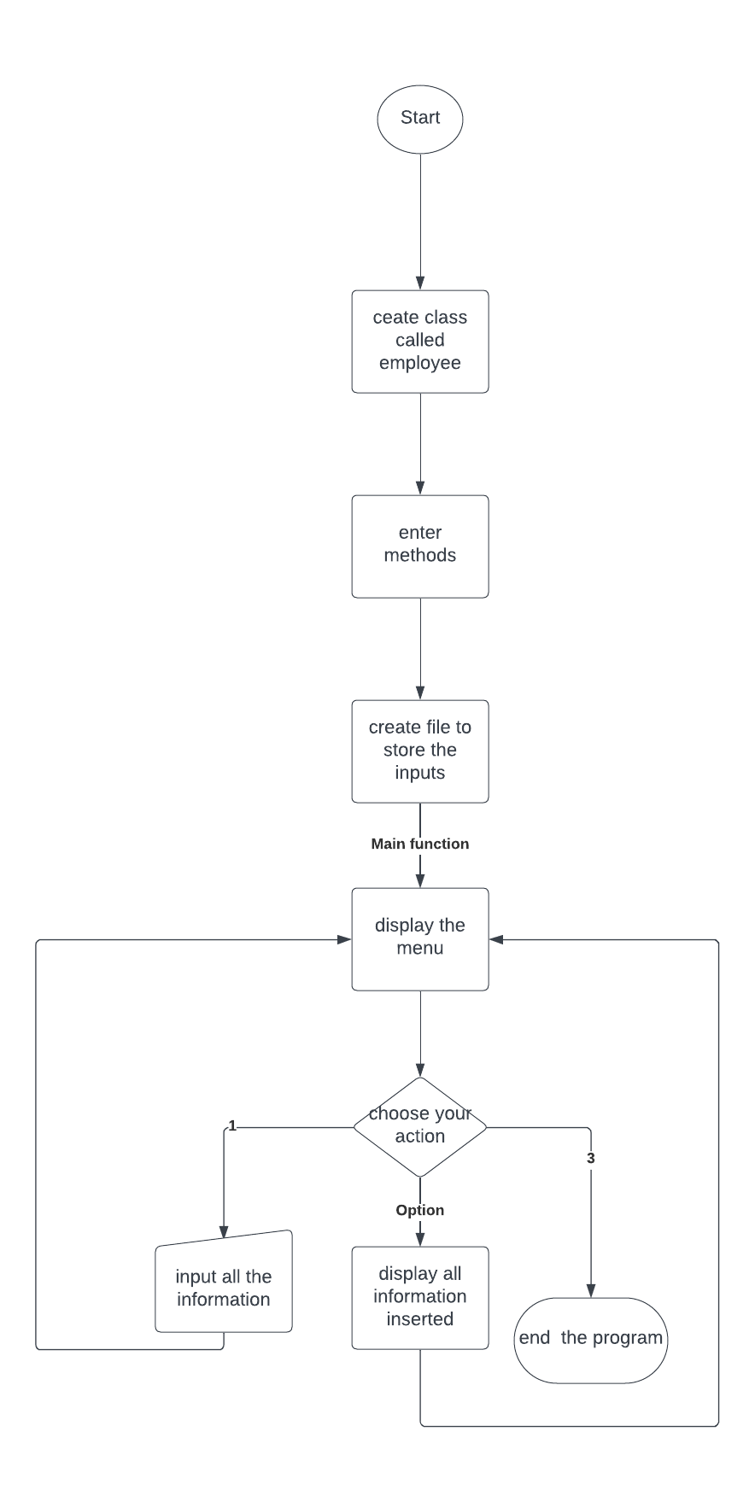

Conclusion
In conclusion, the development of a payroll management system using the C++ programming language offers numerous benefits for organizations seeking to streamline their payroll processes. The system's architecture, key features, and functionality have been thoroughly outlined in this document, highlighting the efficiency, accuracy, and security it provides.
By automating tasks such as employee data management, salary calculation, tax deductions, and payment processing, the payroll management system significantly reduces manual errors and administrative overhead. The use C++ ensures optimal performance and efficiency, making it a reliable choice for handling complex payroll operations.
The document has also emphasized the system's user interface, customization options, and integration capabilities with external systems, enabling organizations to tailor the system to their specific requirements and seamlessly integrate it into their existing infrastructure.
Implementing a payroll management system in C++ brings numerous advantages, including improved productivity, cost savings, compliance with legal and regulatory requirements, and enhanced employee satisfaction. The system's ability to accurately calculate salaries, handle tax deductions, and process payments in a timely manner ensures that employees are compensated correctly and on time.
However, successful implementation and maintenance of the system require careful consideration of potential challenges and adherence to best practices. Organizations must ensure proper training for users, data security measures, and regular updates to keep the system up-to-date with changing tax laws and regulations.
In summary, the payroll management system developed in C++ offers organizations a powerful and efficient solution for managing their payroll processes. By leveraging the capabilities of C++, organizations can automate complex tasks, improve accuracy, and enhance productivity, ultimately leading to a more streamlined and effective payroll management process.

